Task 1: General Knowledge
Hello Pesho,
That is caused when you have an older incompatible version of SSDT (SQL Server Data Tools).
There are a few steps to follow to fix this problem:
- You can download the latest version of SSDT from Microsft’s website
- You have to migrate your existing projects to the newer version
  - To migrate your project you need to Right Click on the Project name and select “Reload Project”. 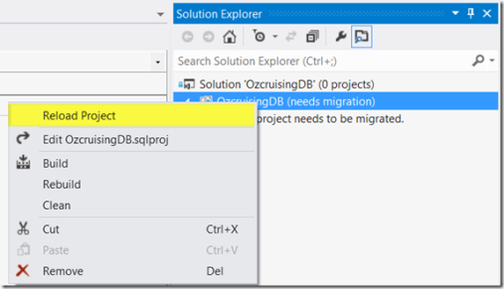
  - This will launch the “One-way Upgrade wizard” which converts your project into the latest version of SSDT: 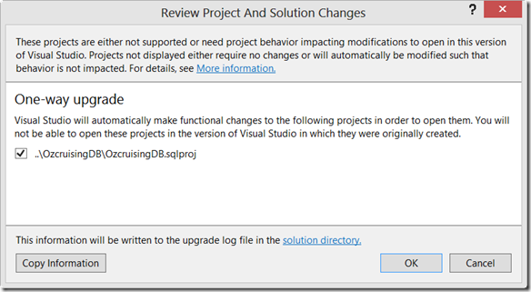
I hope this information helps. Please let me know if I can assist you any further. Thank you in advance.
Regards Mr. Support

Task 2: More Info
Hello Pesho,
Have you tried enabling allowing Nuget to download the missing packages during. You can follow these steps to restore the missing packages. If already done this or you are still getting errors after doing, could you provide me a screenshot or tell me what kind of errors you are getting.

Task 3: Angry Customer
Hello Pesho,
We’re apologizing for the delay with the support for Office 2013 Theme.
The Office 2013 Theme is still under development and it will be delayed for some time due to its complexity. It will be released with the upcoming release in October.
Thank you for contacting us.
I hope this information helps. Please let me know if I can assist you any further. Thank you in advance.
Regards Mr. Support
Task 4: Hash table
Hello Pesho,
I have found three major bugs in our HashTable implementation that are causing your problem. I have fixed them and commented, just above the fixes that I’ve made at your sample project.
I hope this information helps. Please let me know if I can assist you any further. Thank you in advance.
Regards Mr. Support

